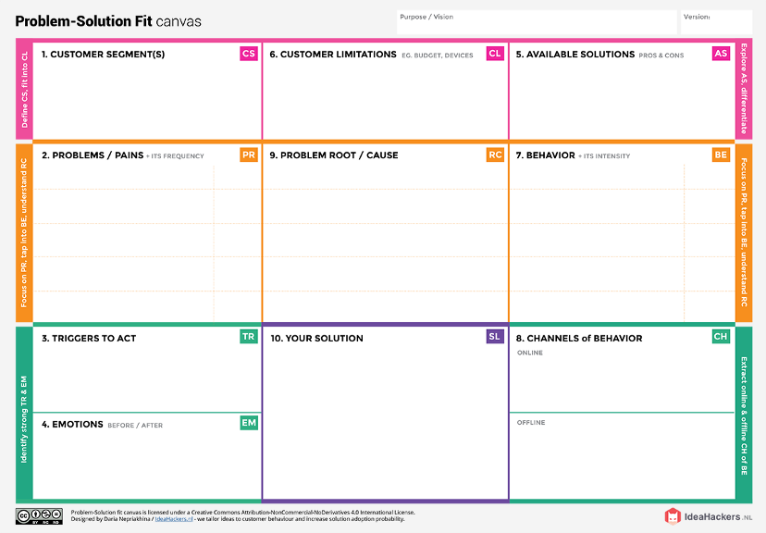

* GPS TRACKING
* order management
* states of inventory

|  |  |
| --- | --- |
| BEFORE | AFTER |
| STRESSFULL | RELIEVED |
| UNCOMFORTABLE  DOING IT MANUAL | COMFORATBLE WITH  THE SOFTWARE |

Retail store stock inventory analytics

* First Time Purchasers
* Loyal Customers
* Purchasers with higher/lower than average order value
* Data Storage
* Tracking
* Order management
* Faster Accessibility
* Hooro enables Retail Shelf Analytics (2017)
* Orca Scan provides Paperless Inventory Tracking (2016)
* Inefficient Warehouse Management
* Un clear Communication
* Inadequate Access
* Overselling
* Spoiled Goods
* Centralized Tracking
* Transparency
* Stock Auditing
* Demand Forecasting
* Go Paperless
* Habitual buying behaviour
* Variety-seeking behaviour
* Dissonance-reducing buying behaviour
* Complex buying behaviour
* Spoiled goods
* Poor production plans
* Inventory loss
* Eliminating mis-picks in your warehouse
* Reducing oversells in your store
* Turn “out of stock” into “in stock”
* Avoiding lost inventory
* Improved decision making
* Better business negotiations
* Significant savings from stock control